DATA STRUCTURES & ALGORITHMS (23CS4111)
Assignment Set 2 - Programming
UNIT-IV: Binary Search Trees

7. A system stores unique integer identification numbers using a Binary Search Tree. Write a C program to insert n values, display inorder, preorder and postorder traversals, search for a specified value, and report whether it exists. Use the output to explain why inorder traversal produces sorted values.

Source Code:
#include <stdio.h>
#include <stdlib.h>

struct node {
int data;
struct node *left, *right;
};

struct node *newNode(int x) {
struct node *p = (struct node *)malloc(sizeof(struct node));
p->data = x;
p->left = p->right = NULL;
return p;
}

struct node *insert(struct node *root, int x) {
if (root == NULL)
return newNode(x);
if (x < root->data)
root->left = insert(root->left, x);
else if (x > root->data)
root->right = insert(root->right, x);
else
printf("ID %d already exists - duplicate ignored.\n", x);
return root;
}

void inorder(struct node *r) {
if (r != NULL) {
inorder(r->left);
printf("%d ", r->data);
inorder(r->right);
}
}

void preorder(struct node *r) {
if (r != NULL) {
printf("%d ", r->data);
preorder(r->left);
preorder(r->right);
}
}

void postorder(struct node *r) {
if (r != NULL) {
postorder(r->left);
postorder(r->right);
printf("%d ", r->data);
}
}

int search(struct node *r, int key) {
while (r != NULL) {
if (key == r->data)
return 1;
r = (key < r->data) ? r->left : r->right;
}
return 0;
}

int main() {
struct node *root = NULL;
int n, i, x, key, choice;

printf("Enter number of values to insert: ");
scanf("%d", &n);
printf("Enter %d integer IDs:\n", n);
for (i = 0; i < n; i++) {
scanf("%d", &x);
root = insert(root, x);
}

printf("\nInorder : "); inorder(root);
printf("\nPreorder : "); preorder(root);
printf("\nPostorder : "); postorder(root);
printf("\n");

do {
printf("\nEnter value to search: ");
scanf("%d", &key);
if (search(root, key))
printf("%d EXISTS in the BST.\n", key);
else
printf("%d does NOT exist in the BST.\n", key);
printf("Search again? (1 = Yes, 0 = No): ");
scanf("%d", &choice);
} while (choice == 1);

printf("\nNote: Inorder visits Left -> Root -> Right. In a BST every value in the\n");
printf("left subtree is smaller than the root and every value in the right subtree\n");
printf("is larger, so the inorder output above is in ascending (sorted) order.\n");
return 0;
}

Output:
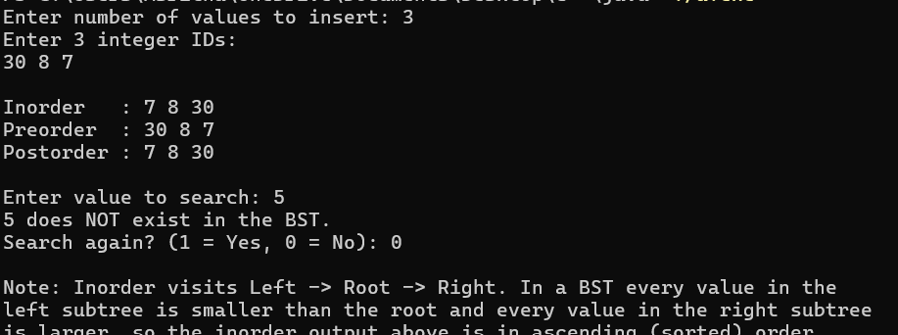

8. Extend a Binary Search Tree program to support deletion. The program should create a BST, delete a user-specified node, correctly handle nodes with zero, one and two children, and display inorder traversal before and after deletion. Test the program separately for all three deletion cases.

Source Code:
#include <stdio.h>
#include <stdlib.h>

int quiet = 0; /* suppresses messages during the internal successor removal */

struct node {
int data;
struct node *left, *right;
};

struct node *newNode(int x) {
struct node *p = (struct node *)malloc(sizeof(struct node));
p->data = x;
p->left = p->right = NULL;
return p;
}

struct node *insert(struct node *root, int x) {
if (root == NULL)
return newNode(x);
if (x < root->data)
root->left = insert(root->left, x);
else if (x > root->data)
root->right = insert(root->right, x);
return root;
}

void inorder(struct node *r) {
if (r != NULL) {
inorder(r->left);
printf("%d ", r->data);
inorder(r->right);
}
}

struct node *minNode(struct node *r) {
while (r->left != NULL)
r = r->left;
return r;
}

struct node *deleteNode(struct node *root, int key) {
struct node *temp;
if (root == NULL) {
printf("Value %d not found in the BST.\n", key);
return NULL;
}
if (key < root->data)
root->left = deleteNode(root->left, key);
else if (key > root->data)
root->right = deleteNode(root->right, key);
else {
if (root->left == NULL && root->right == NULL) {
if (!quiet)
printf("Case 1: node %d is a LEAF (zero children).\n", key);
free(root);
return NULL;
} else if (root->left == NULL || root->right == NULL) {
if (!quiet)
printf("Case 2: node %d has ONE child.\n", key);
temp = (root->left != NULL) ? root->left : root->right;
free(root);
return temp;
} else {
printf("Case 3: node %d has TWO children (replaced by inorder successor %d).\n",
key, minNode(root->right)->data);
temp = minNode(root->right);
root->data = temp->data;
quiet = 1;
root->right = deleteNode(root->right, temp->data);
quiet = 0;
}
}
return root;
}

int main() {
struct node *root = NULL;
int n, i, x, key, choice;

printf("Enter number of nodes: ");
scanf("%d", &n);
printf("Enter %d values:\n", n);
for (i = 0; i < n; i++) {
scanf("%d", &x);
root = insert(root, x);
}

do {
printf("\nInorder before deletion: ");
inorder(root);
printf("\nEnter node to delete: ");
scanf("%d", &key);
root = deleteNode(root, key);
printf("Inorder after deletion : ");
inorder(root);
printf("\nDelete another node? (1 = Yes, 0 = No): ");
scanf("%d", &choice);
} while (choice == 1 && root != NULL);

return 0;
}

Output:
